Diesel motorcycle jacket
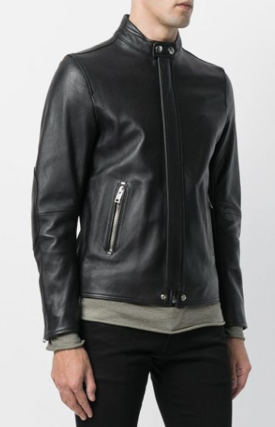
$1100

Diesel black leather lambskin motorcycle jacket with stand-up collar, zips on the cuffs, concealed front closure and zipped side pockets.

